- Try doing two words a night. Bring your spelling sheets in on the following Thursday.
- Practise your best handwriting every time you write the word.
- Check your spelling is correct EVERY SINGLE TIME so that you aren’t spelling it incorrectly.
Word to spell  (Highlight the tricky part of the word in a different colour.)  What does the word mean? | Rainbow Colours | CAPITAL LETTERS | Different font | Look, say, trace, cover, check  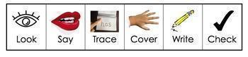 | Find the rule.  Are there exceptions to this rule?  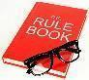 | Etymology  Find the origin of the word e.g Greek - meaning new.   | A word that rhymes with it or a synonym.
science
scene
discipline
fascinate
crescent
fascination
scenery
ascend
descent
scissors

