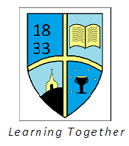
Mellor St Mary CE Primary School
MFL Curriculum Statement 2022

Through our Christian Faith, we acknowledge our responsibility to all, to enrich lives and show love and respect within our school family.
We believe in lifelong learning aiming to equip our children to live life today and for tomorrow rooted in Christian love.
For nothing is impossible with God (Luke 1:37)
Mission:
Our school is the church on the hill; the light that brings Jesus into the lives of all in our community.
Upon this rock I will build my church (Matthew 16:18)
Intent:
At Mellor St. Mary’s C.E. Primary school, we believe that learning a foreign language provides children with a wonderful opportunity to understand the structure of language, which enhances skills in English as well as in the new language being learnt. It exercises the mind, providing direct problem-solving and enhancing the skills involved with code–breaking. It fosters children’s curiosity, giving them the opportunity to understand people from cultures different to our own, which is so vital in developing the underlying respect for all people that our Christianity requires of us. Through learning new languages, the children increase their ability to communicate with other human beings, to show friendship and unite our world. Through learning one language, children often develop the skills required to learn a variety of other languages and they can see patterns and relationships between a range of languages; for example, a speaker of French can often understand Spanish and Italian texts and signs and understand how root words we use in English stem from the original unifying classic languages of Latin and Greek.

The Modern Foreign Language we teach at our school is French. We aim for our children to be able to express their thoughts and ideas in French and to understand and respond to speakers of French in speech, reading and writing. Through discussion and asking questions, we aim that children will continually improve the accuracy of their pronunciation and intonation.

The national curriculum for languages aims to ensure that all pupils:

- Understand and respond to spoken and written language from a variety of authentic sources
- Speak with increasing confidence, fluency and spontaneity, finding ways of communicating what they want to say including through discussion and asking questions, and continually improving the accuracy of their pronunciation and intonation
- Can write at varying lengths, for different purposes and audiences, using the variety of grammatical structures that they have learnt
- Discover and develop an appreciation of a range of writing in the language studied

Subject content:

The formal teaching of French is established in Key Stage 2. Children in Key Stage 1 have access to an after school activity, French Club, which introduces basic greetings and conversational French through learning songs and playing games.

In Key Stage 2 children are taught to:
- Listen attentively to spoken language and show understanding by joining in and responding
- Explore the patterns and sounds of language through songs and rhymes and link the spelling, sound and meaning of words
- Engage in conversations: ask and answer questions: express opinions and respond to those of others; seek clarification and help
- Speak in sentences, using familiar vocabulary, phrases and basic language structures
- Develop accurate pronunciation and intonation so that others understand when they are reading aloud or using familiar words and phrases
- Present ideas and information orally to a range of audiences
- Read carefully and show understanding of words, phrases and simple writing
- Appreciate stories, songs, poems and rhymes in French
- Broaden their vocabulary and develop their ability to understand new words that are introduced into familiar written material, including through using a dictionary
- Write phrases from memory, and adapt these to create new sentences, to express ideas clearly
- Describe people, places, things and actions orally and in writing
- Understand basic French grammar, including feminine and masculine forms and the conjugation of verbs, key features and patterns of the language. Consider how these differ from or are similar to English.

All children will be challenged to be inquisitive, compassionate, courageous and creative learners. They will have opportunities to influence their own learning through age appropriate and progressive themes and topics.

Effective learning characteristics including being ambitious, reflective and imaginative will drive teaching and learning in French.
Our core Christian curriculum drivers will support and enhance the teaching and learning of French through encouraging our children to develop curiosity about other cultures, understand people in other countries and take on an attitude of responsibility to care for our world and all peoples within it, seeking peaceful outcomes in conflicts through identifying with all people, sharing our human experiences and reaching out to others who face humanitarian crises.

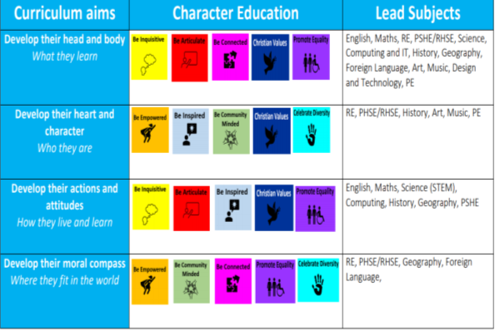

Impact:
As pupils progress, they will be able to compose sentences and communicate more independently in French. They will hopefully wish to experiment with speaking and listening to each other in French outside lessons, acknowledging that French is a vibrant language that is spoken by millions of people as their first language around the world.

Their interest in French-speaking peoples may increase, as they come to appreciate that many countries in deprived parts of the world speak French and that many disadvantaged groups of people, such as cocoa farmers, also speak French, through work linked to Fair Trade and ecological issues.

By the end of Key Stage 2, pupils will know, apply and understand the matters, skills and processes specified in the National Curriculum for learning a modern foreign language.

Our children will have a confident set of communication skills and knowledge, supported by Christian values which they can apply to understanding and serving the needs of people in our world, thus enabling them to be ready for their next stage in education and to live and grow as citizens in the world today.

