Shahne Vickery of Imaginor has put together a series of reflections for each day of Holy Week which is suitable to be sent out to families. The material is free for anyone to download, https://imaginor.co.uk/journey_to_easter and has an arty/crafty theme. Journey Into Easter is inspired by some stunning recently commissioned paintings from the Ethiopian artist Nebiyu Assefa
The material is aimed at 6 - 11 year olds but hopefully parents will be able to adapt it for younger children in the family and everyone will enjoy the craft!
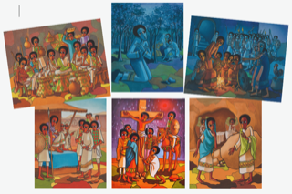
Journey Into Easter With Children
Reflections through art for Holy Week and Easter
written by Shahne Vickery with paintings by Nebiyu Assefa
FREE TO DOWNLOAD

