- Try doing two words a night. Bring your spelling sheets in on the following Friday.
- Practise your best handwriting every time you write the word.
- Check your spelling is correct EVERY SINGLE TIME so you aren’t spelling it incorrectly lots of times.
Word to spell  (Use pictures to help you remember the word.)  MAKE SURE YOU UNDERSTAND WHAT THESE WORDS MEAN. | Rainbow Colours | CAPITAL LETTERS | Different font | Look, say, trace, cover, check  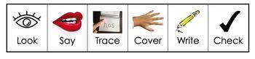 | Find the rule.  Are there exceptions to this rule?  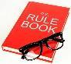 | Etymology  Find the origin of the word e.g Greek - meaning new.   | A word that rhymes with it or a synonym.
grateful
faithful
hopeful
careful
helpful
useful
boastful
beautiful
painful
wonderful

